INVITATION TO TENDER
SAVE THE CHILDREN INTERNATIONAL
^{10th February 2026}
Fundraising Scenario Planning Tool

SUBMISSION DEADLINE: 3rd March 2026

QUESTIONS / CLARIFICATIONS: safa.mustafa@savethechildren.org

FORMAT FOR SUBMISSION: BIDDER RESPONSE DOCUMENT

PART 1: Invitation to Tender
- Introduction to SCI
  - Project Overview and Requirements
  - Award Criteria
  - Instructions & Key Information

PART 2: CORE REQUIREMENTS AND SPECIFICATION
Description of SCI’s specific requirements

PART 3: BIDDER RESPONSE DOCUMENT
Template to be used to submit response to this Invitation to Tender.

PART 1: INVITATION TO TENDER 2
1. INTRODUCTION TO SAVE THE CHILDREN INTERNATIONAL (SCI) 3
2. PROJECT OVERVIEW 4
2.1 CURRENT SITUATION 4
2.2 OBJECTIVE AND VISION 4
2.3 OUTCOME OF TENDER 4
2.4 OUR APPROACH TO PROJECT DELIVERY 5
2.5 DEVELOPMENT CYCLE 5
2.6 GOVERNANCE 5
3. AWARD CRITERA 5
3.1 ESSENTIAL CRITERIA 6
3.2 CAPABILITY CRITERIA (60%) 6
3.3 COMMERIAL CRITERIA (30%) 6
3.4 SUSTAINABILITY CRITERIA (10%) 6
4. VETTING 6
5. BIDDER INSTRUCTIONS 6
5.1 TIMESCALES 6
5.2 SUBMISSION FORMAT & BIDDER RESPONSE DOCUMENT 7
5.3 CLOSING DATE FOR SUBMISSIONS 7
5.4 KEY CONTACTS 7
PART 2 – CORE REQUIREMENTS & SPECIFICATIONS 7
PART 3 – BIDDER RESPONSE DOCUMENT 12
1. INTRODUCTION 13
2. INSTRUCTIONS 14
SECTION 1 - ESSENTIAL CRITERIA 15
SECTION 2 – CAPABILITY & INNOVATION QUESTIONS 18
SECTION 3 – COMMERCIAL QUESTIONS 20
SECTION 4 – SUSTAINABILITY QUESTIONS 21
SECTION 5 – BIDDER SUBMISSION CHECKLIST 21

PART 1: INVITATION TO TENDER

INTRODUCTION TO SAVE THE CHILDREN INTERNATIONAL (SCI)

SCI is the world’s leading independent organisation for children. We save children’s lives; we fight for their rights; we help them fulfil their potential. We work together, with our partners, to inspire breakthroughs in the way the world treats children and to achieve immediate and lasting change in their lives.

Our Vision – a world in which every child attains the right to survival, protection, development and participation.

Our Mission – to inspire breakthroughs in the way the world treats children and to achieve immediate and lasting change in their lives.

We do this through a range of initiatives and programmes, to:

- Provide lifesaving supplies & emotional support for children caught up in disasters (e.g. floods, famine & wars).
- Campaign for long term change to improve children’s lives.
- Improve children’s access to the food and healthcare they need to survive.
- Secure a good quality education for the children who need it most.
- Protect the world’s most vulnerable children, including those separated from their families because of war, natural disasters, extreme poverty or exploitation.
- Work with families to help them out of the poverty cycle so they can feed and support their children.

For more information on the work we undertake and recent achievements, visit our website.

PROJECT OVERVIEW

Save the Children International (SCI) seeks to identify and implement a robust and reliable Scenario Planning Tool to support the development, appraisal and optimisation of private sector fundraising investment strategies across Save the Children member offices in approximately 24 countries. The solution is expected to support an estimated 100-200 users across a diverse range of country contexts.
This initiative supports SCI’s 2030 strategic objectives. Which sets out SCI’s ambition to strengthen long-term financial resilience and impact for children through a more diversified and sustainable funding structure. Prioritising an acceleration of private fundraising, alongside a continued strong institutional funding base, reducing exposure to funding volatility and enhanced organisational independence.
In this context, SCI’s private sector fundraising strategy emphasises:
- Growth of flexible and diversified funding streams.
- Improved cost efficiency.
- Enhanced digital, data and evidence capabilities to support strategic decision-making.
Together, these priorities aim to enable SCI to make investment decisions driven by strategic objectives and evidence, and to support more effective allocation of resources across markets, channels and products.

2.1 CURRENT SITUATION
Currently, SCI does not possess a single, standardised tool or template for modelling private sector fundraising returns across the movement. While some member offices utilise locally developed models or external service providers, levels of sophistication, consistency and comparability vary significantly.

This fragmentation limits SCI’s ability not only to conduct consistent scenario analysis, compare investment options across markets and channels but also to support evidence-based decision-making at both global and member levels.

2.2 OBJECTIVE AND VISION
This tender seeks to identify the most effective route to delivering a scenario planning tool that supports SCI’s global fundraising framework and can be applied across diverse contexts.
The tool will Enable SCI and its member offices to model, understand, and evaluate proposed scenarios for private sector fundraising investment and expected returns across a 10-year time horizon.
The envisaged solution will support consistent modelling and scenario analysis, allowing users to assess alternative approaches, test assumptions, and compare outcomes across markets, channels and products. Through this, SCI aims to strengthen strategic decision-making, improve prioritisation of investments, and enhance the organisation’s ability to plan for sustainable, long-term fundraising growth.

2.3 OUTCOME OF TENDER
Framework Agreement (Fixed price or Non-Fixed Price) – the successful supplier(s) will be awarded a ‘Framework Agreement’. Within the Framework Agreement the terms of supply (e.g. indemnities, liabilities, warranties etc.) shall be agreed, as will the conditions of supply (e.g. specifications, lead times etc.). The Framework Agreement does not commit SCI to any purchases or specific volumes. Any future purchases which will be completed under separate Purchase Orders which will be governed and linked to the original Framework Agreement.

Further detail on the specific requirements of the project can be found in Part 2 (Core Requirements & Specifications) of this Tender Pack.

2.4 OUR APPROACH TO PROJECT DELIVERY
This project is intended to be delivered through Agile Scrum. A high-level view of our approach for Agile projects is outlined below, Save the Children International expect the project to work with this approach and expect vendors to demonstrate how they will align their delivery to this.

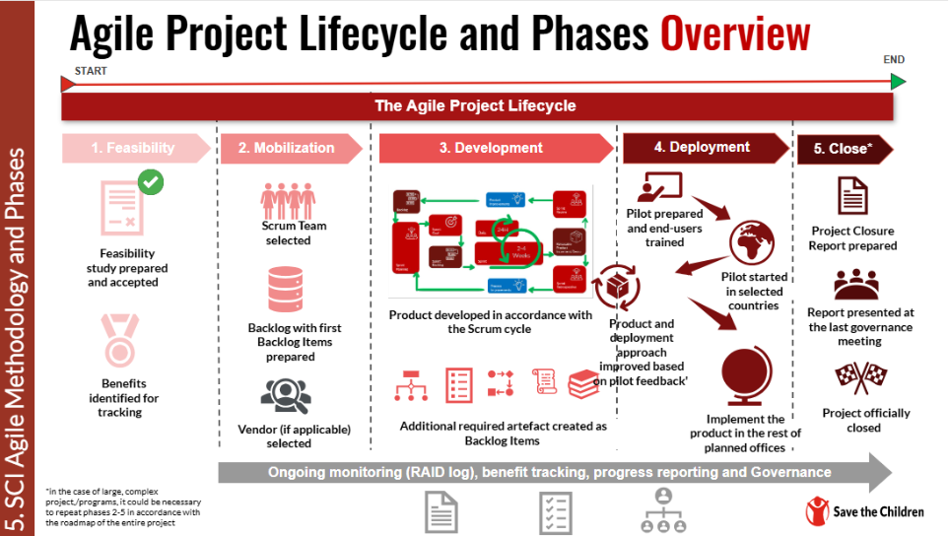

2.5 DEVELOPMENT CYCLE
We expect design and development of a global modular solution that facilitates the deployment of the end-to-end solution. It is expected that this will happen iteratively, with continuous input and feedback from the project team, to ensure a workable solution for Save the Children.

The implementation partner is expected to complete the solution design and development for any modules that they propose to deliver as part of the end-to-end solution for Save the Children, documenting this on an agreed format with SCI.
2.6 GOVERNANCE
The successful vendor(s) will be expected to comply with SCI’s internal project and IT governance, and each phase will need to go through the relevant internal governance bodies and approvals.

AWARD CRITERA

SCI is committed to running a fair and transparent tender process and ensuring that all bidders are treated and assessed equally during this tender process. Bidder responses will be evaluated against four weighted categories of criteria: Essential Criteria, Capability Criteria, Commercial Criteria, and Sustainability Criteria.

3.1 ESSENTIAL CRITERIA
Criteria which bidders must meet in order to progress to the next round of evaluation. If a bidder does not meet any of the Essential Criteria, they will be excluded from the tender process immediately. These criteria are scored as ‘Pass’ / ‘Fail’.

3.2 CAPABILITY CRITERIA (60%)
Criteria used to evaluate the bidder’s ability, skill, innovation capacity and experience in relation to the requirements. Bids will be evaluated against the same pre-agreed Criteria.

3.3 COMMERIAL CRITERIA (30%)
Criteria used to evaluate the commercial competitiveness of a bid. Bids will be evaluated against the same pre-agreed Criteria.

3.4 SUSTAINABILITY CRITERIA (10%)
Criteria used to evaluate the impact a supplier has on the environment, local economy and community. Bids will be evaluated against the same pre-agreed Criteria.

VETTING

Successful bidders must be successfully vetted. This involves checking bidders and key personnel against Global Watch Lists, Enhanced Due Diligence Lists and Politically Exposed Persons Lists.
The vetting of bidders will be completed after the award decision and prior to any contract being signed, or orders placed. If any information provided by the Bidder throughout the tender process is proved to be incorrect during the vetting process (or at any other point), SCI may withdraw their award decision.

BIDDER INSTRUCTIONS

5.1 TIMESCALES
Activity | Date
Issue Invitation to Tender | 10th February 2026
Deadline for questions from bidders | 16th February 2026
Deadline for bid submission | 3rd March 2026
Shortlisted bidder presentations | During the week of 16-20 March 2026
Contract award | 30th March 2026

The above dates are for indicative purposes only and are subject to change.

5.2 SUBMISSION FORMAT & BIDDER RESPONSE DOCUMENT

Bidders wishing to submit a bid must use the Bidder Response Document template in Part 3 of this document. Any responses received using different formats, or incomplete responses, will not be accepted.

This document allows bidders to submit all the required information and be evaluated fairly and equally against the Essential, Capability and Commercial Criteria. Bidders may also be required to submit supporting documentation. Further instructions can be found within the document in Part 3 of this pack.

Responses can be submitted by:

Electronic Submission via ProSave
Bid submissions must be made exclusively through ProSave. Bidders are required to be registered on the Ariba Network prior to submission and must submit their responses in accordance with the guidance set out in the document below:
- Ariba Network Self registration.
- Bidding on a Sourcing event.


5.3 CLOSING DATE FOR SUBMISSIONS

Your bid must be received, no later than 3rd March 2026
Responses must remain valid and open for consideration for a period of no less than 90 days.

5.4 KEY CONTACTS

All questions relating to the tender should be sent via email to:

Name | Email Address
Safa Mustafa | Safa.mustafa@savethechildren.org

Where the enquiry may have an impact on other bidders within the process, Save the Children will notify all other Bidders to maintain a fair and transparent process.

PART 2 – CORE REQUIREMENTS & SPECIFICATIONS

Introduction to Scenario Planning Tool
As part of SCI’s private sector fundraising activities, the organisation routinely undertakes financial planning forecasting and scenario analysis to inform investment decisions across markets, channels and products. These activities are essential to understanding expected returns assessing risk and supporting strategic decision making within SCI and its member offices.
Currently, SCI does not have a single standardised scenario planning tool to support this work consistently across the movement. While some members have developed local models or engage external service providers, others rely on tools provided by SCI during global planning exercises. Previous SCI-developed tools, such as the DM insights 10 Year forecasting tool, have been utilised but have faced several limitations, including performance issues usability challenges, complexity of inputs, and an overabundance of detailed outputs that can obscure key strategic insights. As a result, approaches to modelling and scenario analysis vary and the ability to compare prioritise and evaluate investment options consistently is constrained.
As SCI enters new strategic period, and as private sector fundraising continues to play a critical role within the global fundraising framework, there is an increasing need for a reliable robust and user-friendly tool that enables stronger prioritisation and evidence-based decision-making. A consistent approach to scenario planning will support clearer understanding of long-term implications of investment choices and enhance the quality of strategic discussions across the organisation.

Specific Requirements
Bidders are expected to design a global Scenario Planning Tool supporting the English language and can be applied across diverse contexts and used consistently across SCI and its member offices.
The tool must enable consistent modelling, scenario analysis, and appraisal of private sector fundraising investments to inform strategic decision-making. As a minimum, the solution must be capable of:

- Calculating the uplift in net income generated through additional capital investment across key private sector fundraising levers including Single Giving, Regular Giving, Lifetime Value, Major Donors and Legacies.
- Calculating return on investment (ROI), breakeven points, and net income for a cohort of newly acquired donors.
- Modelling investment and re-investment level required to achieve defined income uplift targets across different time horizons (e.g. 3, 5 and 10 years).
- Modelling the impact of improvements in one or more Key Performance Indicators (KPIs) on return on investment and net income outcomes across different time horizons.

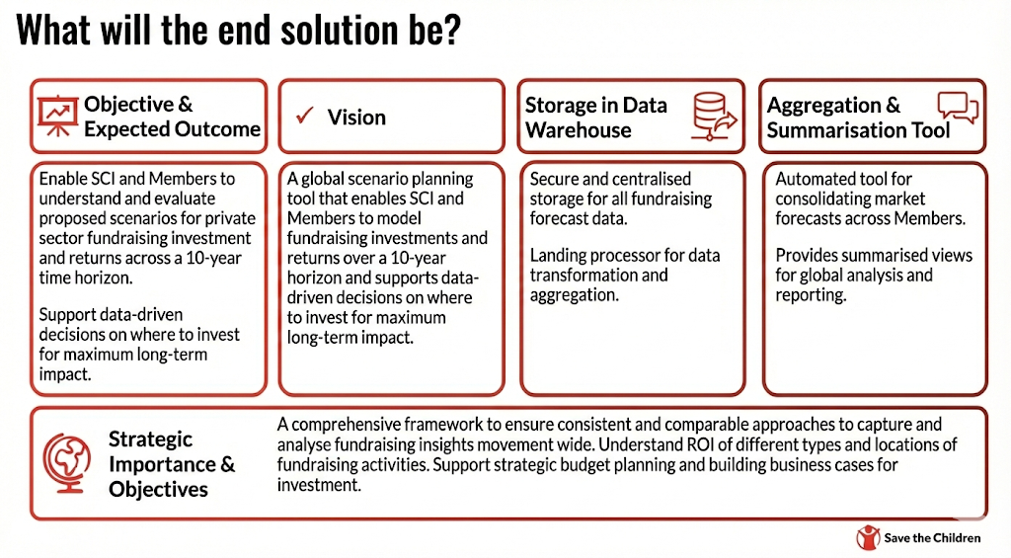

Key Goals
- Provide a long-term scenario planning tool to support the identification and comparison of optimal markets, fundraising channels and programmes for additional Individual Giving (IG) investment.
- Accommodate the specific characteristics and maturity levels of Member programmes and markets, with an initial focus on the largest fundraising programmes, while remaining intuitive and user-friendly for a broad range of users.
- Deliver a reliable and robust solution that can be maintained over time to meet future business needs.

Out of Scope
- Provide a single-donor level lifetime value view intended to support detailed targeting, profiling, or segmentation decisions.
- Produce or replace detailed operational or programme-level budgeting tools for fundraising activities.
- Enable tracking of actual performance against projections, ongoing monitoring of actuals, or re-forecasting functionality.
- Replace or act like the sole fundraising planning or financial management tool used across the movement.

Functionality and Technical Requirements

The tool must be intuitive and easy to adopt, enabling SCI global stakeholders, fundraising directors and their teams to use it effectively with minimal training or onboarding.
The following minimum technical and functional requirements have been defined by SCI’s technical and fundraising stakeholders to ensure the proposed solution meets core modelling and scenario planning needs. Bidders should demonstrate how their solution meets these requirements and clearly highlight any assumptions, discrepancies or limitations:

Category | Minimum Required Functionality | Strategic Context / Technical Requirements
Overall | • Enable local currency and USD.  • Provide a single, user‑friendly consolidated inputs page for future assumptions and sensitivity analysis supported by clear and contextual KPI definitions.  • Produce future monthly revenue projections for 10 years for each acquisition cohort.  • Deliver summary reporting and export functionality covering: Investment Amounts, Channels, Donors Acquired, Donors Lost, Active Regular Giving volumes, Gross & Net Income, Breakeven Points, and Recruitment Cohort ROI. | Bidders must describe how their solution enables the easy running and comparison of different scenarios. The tool must explicitly address previous challenges related slow performance, recalculation delays, system instability, and unclear system structure. The solution must also include appropriate protections to prevent users from editing underlying formulae or structural components.  Where relevant, bidders should outline any assumptions, dependencies or limitations associated with their proposed technical approach.
Acquisition: Single Giving (SG) & Regular Giving (RG) | • Capture CPA and stewardship costs by year, average gift by year; acquisition volumes by calendar month; monthly survival rates; delinquency rate; and relevant conversion metrics.  • Allow acquisition investment amounts to be entered and allocated by month to reflect seasonality.  • Track both the existing supporter base at the start of the forecasting period (with optional cohort splits) and newly acquired donors.  • Support modelling of two‑step recruitment journeys (e.g., Lead Generation or SMS to Regular Giving), including lead volumes, associated costs, contact‑to‑conversion rates, and subsequent Regular and Single Giving outcomes.  • Support non‑monthly Regular Giving frequencies (e.g : quarterly, bi‑annual, annual) including proration and schedule‑specific churn and arrears handling.  • Provide separate scenario planning modes or parameter sets for Single Giving and Regular Giving acquisition, with the ability to run and compare scenarios side‑by‑side.  • Flexibly accept Digital and DRTV KPIs, either separately or combined and allow outputs to be viewed separately or in aggregate to accommodate multi‑channel or non‑attributed donors.  • Where relevant, the solution should allow optional manual entry of granular cost lines (e.g., paid media, concepting, print/production) in addition to CPA, without making this a mandatory requirement across all scenarios. | Must allow the user to input acquisition volume targets first, rather than driving volumes solely from a total available acquisition budget. Must provide features like a calculator sheet to convert various member retention/attrition styles to the standardised version required by the tool.
Development: Lifetime Value | • Upgrade: Capture upgrade rates and values, including timing post-first gift, as well as downgrade behaviour, and link upgrades to the eligible donor pool.  • Retention: capture first‑year and multi‑year retention rates by segment, channel, and giving type and enable forecasting based on historical retentions trends.  • Reactivation, Winbacks and Saves: Capture eligibility criteria, success rates, costs, and resulting value; link to the available lapsed donor pool.  • Second Gift: Capture second‑gift rates and timing for Single Giving to support value development modelling.  • Single Giving to Regular Giving (SG to RG) Conversion: Support SG‑to‑RG conversion as a distinct Regular Giving acquisition route, linked to the SG base, including tracking of conversion rates, associated costs, and value. | -
Major Giving & Legacies | • Major Giving (MG): Support modelling of new and repeat major donors across defined value bands; including the ability to input associated staff and overhead costs.  • Legacies: Include KPIs for legacy marketing programme and the ability to track pipeline size and percentage of investment.  • Corporate & Foundation: Provide manual input sections for income projections and associated expenditure to enable a complete Individual Giving view in consolidated summaries. | Bidders must specifically detail how their solution handles these two critical levers of our individual giving program, as they were not included in previous tools.
Technical Delivery | • Allow users to choose input currency and hide/unhide modules (RG, SG, MG).  • Support allocation of staff and fixed costs to programme elements and provide simple inflation application to costs/values.  • Include a converter sheet to standardise different member retention/attrition styles into the tool’s required format.  • Protect underlying formulae/structure from user edits and ensure fast recalculation/stability when modelling multiple 10‑year scenarios. | The tool does not anticipate compatibility needs with Member CRM systems or other Global systems (BINGO, INDIGO), other than sharing across KPI definitions. Bidders must advise on the best technical approach: a master excel file provided to users (like the DMI tool) or a cloud-based system.

PART 3 – BIDDER RESPONSE DOCUMENT

INTRODUCTION

This document MUST BE USED by Bidders wishing to submit a bid. It is linked into 5 sections detailed below:

- Section 1 – Essential Criteria
- Section 2 – Capability & Innovation Questions
- Section 3 – Commercial Questions
- Section 4 – Sustainability
- Section 5 – Bidder Submission Checklist

The Bidder is required to sign a copy of the Check list in Section 5 as part of their submission.

2. INSTRUCTIONS

Within each section there are instructions providing guidance to the bidder on what information is required. This guidance details the MINIMUM requirements expected by SCI.

For your bid response please complete all the sections in this Part 3 below.

Where you believe there is an alternative specification or solution to the requirements in Part 2 above you may submit an additional bid response. For avoidance of doubt this will require you to submit two (2) separate bid response documents. Both bids shall be evaluated following the same process as outlined in Part 1 above.

If a Bidder wishes to add further information, this is acceptable, but the additional information should be limited to only items that are relevant to the tender.

- For the avoidance of doubt, bidders are required to complete all items within the Bidder Response Document unless clear instruction is provided otherwise.
- If a Bidder does not complete the entire Bidder Response document, their submission may be declared void.
- If a Bidder is unable to complete any element of the Bidder Response Document, they should contact Save the Children through the using the contact details provided for guidance.

By submitting a response, the bidder confirms that all information provided can be relied upon for validity and accuracy.

SECTION 1 - ESSENTIAL CRITERIA
INSTRUCTIONS – Bidders are required to complete all sections of the below table.
 | Yes/No | Bidder Comments  Include Links to Documents if Relevant
Yes/No Criteria
Bidder accepts Save the Children’s ‘Terms and Conditions of Purchase’ included within the Bidder Submission Checklist of the ITT, and that any work awarded from this tender process will be completed under the agreed ‘Terms and Conditions of Purchase’.
The bidder and its staff (and any sub-contractors used) agree to comply with SCI and the IAPG’s policies and code of conducts listed within the Bidder Submission Checklist of the ITT, throughout this tender process and during the term of any contract awarded.
- Child Safeguarding Policy
- Anti-Fraud, Bribery & Corruption Policy
- Slavery & Human Trafficking Policy
- IAPG Code of Conduct
- Sustainability Policy
The bidder must not be a prohibited party under applicable sanctions laws or anti-terrorism laws or provide goods under sanction by the US or EU.
The bidder confirms it is fully qualified, licenses and registered to trade with Save the Children (including compliance with all relevant local Country legislation). | Yes/No | Comments
 | Requirement | Bidder response/ Attachments
 | Legitimate Business Address
 | Tax Registration Number & Certificate
 | Business Registration Certificate
 | Trading License
Essential Technical Capabilities
The bidder confirms that the proposed solution is scalable and can accommodate increased data volumes and an increased user base.
The bidder confirms that the proposed solution meets recognised information security and data protection standards, including GDPR compliance and secure handling of personal data (PII), and can evidence this upon request.
The bidder confirms that they have the technical skills and experience to deliver the proposed solution as detailed in the "Technical Implementation's Capabilities" section under tab 2 Capability
Essential Collaboration Criteria
Is the bidder willing to collaborate with other vendors and organisations as part of the implementation of the end-to-end solution? (including, but not limited to, modules development, enhancements of pre-existing tools)

SECTION 2 – CAPABILITY & INNOVATION QUESTIONS

Instructions – Bidders are required to complete all sections of the attached spreadsheet.
Please complete this section on the attached spreadsheet, entitled “SPT Bidder Response”. This section can be found in Tab “2. Capability Criteria”.

SECTION 3 – COMMERCIAL QUESTIONS

Instructions – Bidders are required to complete all sections of the attached spreadsheet.
Please complete this section in the attached document entitled “SPT Bidder Response”. This section can be found in Tab “3. Commercial”.

SECTION 4 – SUSTAINABILITY QUESTIONS

Instructions – Bidders are required to complete all sections of the attached spreadsheet.
Please complete this section in the attached document entitled “SPT Bidder Response”. This section can be found in Tab “4. Sustainability Criteria”.

SECTION 5 – BIDDER SUBMISSION CHECKLIST
We, the Bidder, hereby confirm we have completed all sections of the Bidder Response Document:
No | Section |  |  | Please Tick
1. | Section 1 – Essential Criteria
2. | Section 2 – Capability & Innovation Questions
3. | Section 3 – Commercial Questions
4. | Section 4 - Sustainability Questions
We, the Bidder, confirm we have uploaded all the required information and supporting evidence:
Section |  | Required Document / Evidence |  |  |  | Please Tick
Essential Criteria Evidence |  | Proof of legitimate business address
 |  | Copy of tax registration number & certificate
 |  | Copy of business registration certificate
Capability Criteria Evidence |  | Completed Bidder Response Document
 |  | Supporting Financial Documents
Commercial Criteria Evidence |  | Completed Bidder Response Document
We, the Bidder, hereby confirm we compliance with the following policies and requirements:
Policy |  |  | Policy / Document |  | Signature
Terms & Conditions of Bidding |  |  | 
Terms & Conditions of Purchase |  |  | Please Click here
Supplier Sustainability Policy  and the included mandatory policies |  |  | Please Click here

We confirm that Save the Children may in its consideration of our offer, and subsequently, rely on the statements made herein.
Signature: | …………………………………………………..
Name: | …………………………………………………..
Title: | …………………………………………………..
Company: | …………………………………………………..
Date: | …………………………………………………..

