FEDERAL MINISTRY OF HEALTH

NATIONAL MALARIA ELIMINATION PROGRAMME
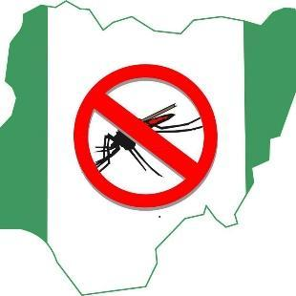

National Protocol for the Conduct of Seasonal Malaria Chemoprevention
End of Round Programmatic Assessment

OCTOBER 2025

CONTENTS
CONTENTS 2
ACKNOWLEDGEMENTS 4
ABBREVIATIONS AND ACRONYMS 6
BACKGROUND 7
ASSESSMENT OBJECTIVES 10
Primary objectives 10
Secondary objectives 10
KEY SMC ASSESSMENT VARIABLES 11
METHODS 13
Assessment design 13
Assessment Area 13
Assessment population 13
Inclusion criteria 13
Exclusion criteria 13
Sample size 13
Sampling frame and sampling design 14
DATA COLLECTION 16
Assessment Tools 16
Data Collection Procedures 16
MANAGEMENT OF FIELDWORK 17
DATA MANAGEMENT 18
Data analysis 18
ETHICAL CONSIDERATIONS 18
SCHEDULE FOR COVERAGE ASSESSMENT 18
REFERENCES 19
Annex 1: 2025 SMC Coverage Assessment Questionnaire 20

ACKNOWLEDGEMENTS
We express our profound gratitude to the Coordinating Minister of Health and Social Welfare, Prof. Muhammed Ali Pate, for his vision of a malaria free nation and all principal officers in the Federal Ministry of Health and the National Malaria Elimination Programme for championing the malaria-free Nigeria vision. Further commendations to the Commissioners of Health, the Directors of Public Health and the Programme Managers of the implementing states at the time of developing this national protocol
List of Contributors
- Dr Godwin Ntadom, Director/National Coordinator, NMEP
- Chukwu Okoronkwo, Director/Head SMEOR Branch,NMEP
- Prof. Olugbenga Mokoulu, Malaria Technical Director, NMEP
- Dr Nnenna Ogbulafor, Head of Case Management Branch, NMEP
- Festus Okoh, Deputy Director, Monitoring and Evaluation Branch, NMEP
- Dr Jamilu Ibrahim Nikau, Senior Programme Officer, NMEP-GF-PMU
- Dr Emmanuel Shekarau, Case Management Branch, NMEP
- Dr Aminu Haruna, Monitoring and Evaluation Branch, NMEP
- Dr Chinedu Chukwu, Senior M&E Manager, MSH
- Dr Victoria Erinle, Senior Technical Manager, MSH
- Cyril Ademu, M&E Manager -GF, NMEP
- Olatunde Adesoro, Programme Director (SMC) Malaria Consortium
- Dr Olusola Oresanya, Country Technical Coordinator, Malaria Consortium
- Dr Sol Richardson, Epidemiologist, Malaria Consortium
- Dr Abimbola Phillips, Research Specialist, Malaria Consortium
- Jane Onyilo, Monitoring and Evaluation Manager, Malaria Consortium
- Ikechukwu Ebenezer, Senior M&E Specialist, Malaria Consortium
- Dr Uwem Inyang, PMI-USAID
- Dr Abimbola Olayemi, Management Sciences for Health
- Comfort Boman, Management Sciences for Health
- Dr Chukwuyem Okoh, Malaria Logistics Support Manager, USAID GHSC-PSM
- Frank Oronsaye, Senior MEAL Manager, CRS
- Dr Muhammad A. Kumo Technical Malaria Specialist, CRS
- Dr Nickson H Hyeladendu, Program Manager, CRS
- Ahmad Sani, SMC Manager Gombe State SR – NMEP
- Olabisi Ogunmola, M&E Specialist Malaria Consortium
- Dr Jennifer Chukwumerije, Technical Specialist, Malaria Consortium
- Oyetunji Bashir A., SMC Manger Kwara State SR – NMEP
- Dr Sherifa Ibrahim State Coordinator. USAID/President Malaria Initiative for States Project. Zamfara state

ABBREVIATIONS AND ACRONYMS

AQ | Amodiaquine
CAPI | Computer-assisted personal interviews
CDD | Community Drug Distributors
CI | Confidence interval
DOT | Directly observed treatment
EA | Enumeration Area
ESS | Effective sample size
GPS | Geographical Positioning System
HF | Health Facility
ICC | Intra-cluster correlation
LGA | Local Government Area
LLIN | Long-lasting insecticide nets
M&E | Monitoring and Evaluation
NHREC | National Health Research Ethics Committee of Nigeria
NMEP | National Malaria Elimination Programme
NMIS | National Malaria Indicator Survey
NPHC | Population and Housing Census of the Federal Republic of Nigeria
NPopC | National Population Commission
RBM | Roll Back Malaria
RDT | Rapid Diagnostic Test
SMC | Seasonal Malaria Chemoprevention
SP | Sulfadoxine-pyrimethamine
WHO | World Health Organization

BACKGROUND
Malaria remains a disease of public health importance globally. According to the 2022 World Malaria Report, Nigeria accounts for 27% of the global estimated malaria cases and 31% of the estimated deaths due to malaria. The country accounted for an estimated 55% of malaria cases in West Africa in 2022 (WHO, 2023). Children under 5 years remain the most vulnerable group affected by malaria. According to the 2023 World Malaria Report (WHO, 2023) children under five years accounted for 76% of all malaria deaths worldwide in 2022, with Nigeria accounting for 26.8% of global malaria cases and 38.5% of global malaria deaths in children aged under 5 years. As part of other high-impact interventions for the control of malaria in Nigeria, the Federal Ministry of Health adopted the World Health Organization (WHO) recommendation for Seasonal Malaria Chemoprevention (WHO, 2012) to prevent malaria in those most vulnerable to the disease’s effects in the Sahel sub-region, where malaria transmission is highly seasonal and most morbidity and mortality occur during the rainy season.
Seasonal Malaria Chemoprevention (SMC) is the administration of four monthly courses of sulfadoxine-pyrimethamine (SP) and amodiaquine (AQ), or SPAQ, to children between 3 and 59 months during the rainy season in the Sahel sub-region where malaria transmission is highly seasonal and the majority of clinical malaria cases (>60%) occur during a short period of 3-4 months (WHO, 2012). The objective of SMC is to maintain therapeutic antimalarial drug concentrations in the blood throughout the period of greatest risk. SMC is safe, feasible, effective, and cost-effective for the prevention of malaria among children under five. WHO estimates that SMC can prevent 75% of malaria episodes and severe malaria cases in the target population (WHO, 2012).
SMC involves the administration of SPAQ to eligible children in yearly rounds of four or five monthly courses (cycles) during the peak period of malaria transmission (usually between June to November) with distribution cycles approximately 28 days apart. The medicines are typically administered and recorded at households through door-to-door campaigns by Community Drug Distributors (CDDs) for three to four days per cycle. Each monthly course consists of one dispersible tablet of SP and three daily dispersible tablets of AQ. A dose of SP and the first dose of AQ are administered as directly observed treatment (DOT), that is, by or under the supervision of CDDs to ensure that the tablets are correctly dissolved and that the child fully ingests the drugs without spitting them out or vomiting. Children who vomit or spit out the drugs within 30 minutes are given a second dose under the supervision of the CDDs. The remaining two doses of AQ are administered by the caregiver – one each over the following two days; that is, the CDDs leave a blister with the two remaining tablets with caregivers and provide instructions on how to administer and record the dose on the SMC Child Record Card. If a child vomits or spits out the second or third dose of AQ, caregivers are encouraged to request a replacement dose from the nearest health facility. Lead mothers – who are well-known, older, influencers and respected community women – are recruited to visit the households from the second day of distribution and remind the caregivers to give the last two doses as instructed.
Children under 3 months or over 5 years, children severely ill with fever, or taking sulfa-containing medications, and those with known allergies to SP or AQ are excluded from SMC. CDDs mark each house they have visited, indicating whether treatment was completed or not. They are instructed to refer children with fever to the nearest health facility, where they should be tested for malaria using a rapid diagnostic test. If the test result is negative, children are given SP and the first dose of AQ by the health facility worker, with the remaining two doses of AQ given to the caregiver for administration over the following two days.
The SMC programme is integrated with a robust monitoring and evaluation component that includes in-process and end-of-process assessment of key indicators to measure progress and achievements of results. Of note is the end-of-round coverage assessment that is conducted to measure the coverage and quality of implementation of the SMC programme after the four or five cycles.
Nigeria adopted the WHO policy recommendation on SMC in 2014 following the conduct of pilot studies in seven local government areas (LGAs) in three of the States in the Sahel area; Jigawa, Kano, and Katsina. Thus, in 2015, the implementation of SMC took place in 6 LGAs in Jigawa and Katsina, which expanded to 52 LGAs in Sokoto, Zamfara, Jigawa, and Borno in 2016. By 2020, the nine Sahel states eligible for SMC intervention (Figure 1) had full implementation of SMC in all their LGAs except for Bauchi State with only 10 SMC-implementing LGAs. In 2022, the implementation of SMC covered the 21 eligible States with a total of 411 LGAs.
Currently, over 28 million children aged 3–59 months are eligible for SMC in the implementing states. The malaria risk stratification mapping that was conducted by the National Malaria Elimination Programme (NMEP) as part of the review of the 2021 - 2025 National Malaria Strategic Plan (NMSP), identified the need to expand the geographical scope of the SMC implementation scale to include States in the non-Sahel region that are emerging with similar rainfall pattern, thus similar malaria transmission intensity The additional States (Figure 1) was proposed in the NMSP 2021–2025 and are now being implemented with the support of the NMEP and its Roll Back Malaria (RBM) partners.
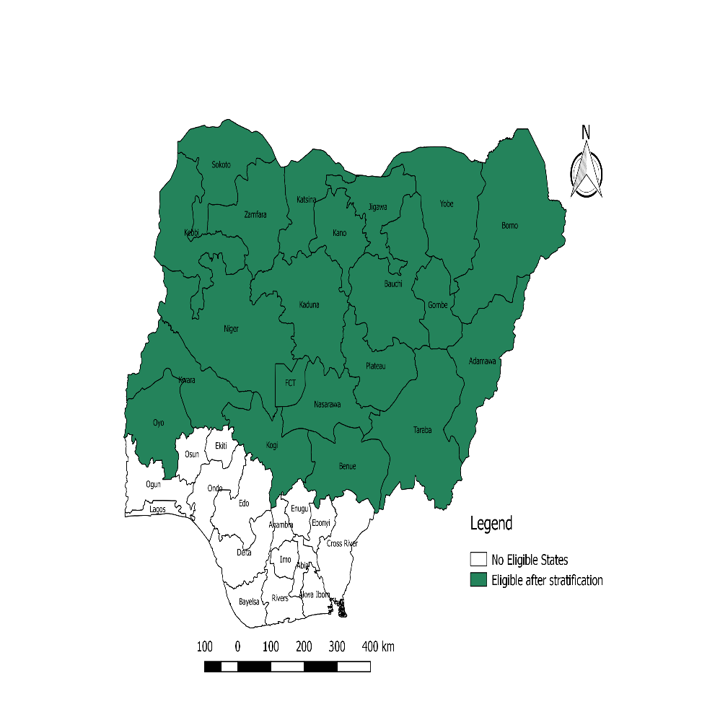
Figure 1: Twenty-One Eligible States of Nigeria for Seasonal Malaria Chemoprevention covered in 2022

This protocol was developed to guide the collection of end-of-round coverage data after the implementation of the last cycle of SMC which will be used to measure key performance indicators over the entire round for each year of SMC implementation.

ASSESSMENT OBJECTIVES
The overall goal of the end-of-round coverage assessment is to establish the SMC coverage and determine the quality of implementation of the fourth/fifth cycle and the overall SMC campaign in the implementing states. The primary and secondary objectives of the assessment are listed below.

Primary objectives

The primary objectives of the assessments are to:

- Determine the proportion of self-reported SPAQ administration among the targeted population (children between 3 and 59 months) during the cycles.
- Ascertain the level of adherence to the SMC protocol by the CDDs during the cycles Determine the level of adherence to the SPAQ administration regimen by caregivers of targeted children on days two and three of the cycles in the SMC round.
- Ascertain the role of SPAQ in the prevention of fever attributed to malaria and assess if SPAQ had an additive effect in the prevention of fever attributed to malaria in children that have received all 4/5 cycles of SPAQ in contrast to those that haven’t received all 4/5 cycles. (i.e. 3, 2, and 1 cycles received)
- To determine the compliance to DOTs by CDDs during the SPAQ administration

Secondary objectives
The secondary objectives are to:
- Identify the most accessed information channel on SMC by caregivers of targeted children
- Assess the adequacy of information given to mothers/ caregivers of targeted children on what to do in the event of an adverse reaction to SMC medicine
- Ascertain the proportion of ineligible children age 5-10 years that were administered SPAQ during the SMC
- Explore the ideational factors such as perceptions and attitudes related to SMC, such as caregivers' belief that SPAQ prevents malaria and perceived self-efficacy to administer SPAQ
- Ascertain the relationship between the level of protection from fever from malaria and doses/cycles of SPAQ received in Children under 5
- Assess the relationship between DOTS (Directly Observed Therapy) and the level of adherence to the SPAQ administration regimen by caregivers of targeted children on days two and three during the cycles
- To assess the effectiveness and user experience of the NMEP One App in tracking and managing Seasonal Malaria Chemoprevention (SMC) implementation

KEY SMC ASSESSMENT VARIABLES
The assessment questionnaire will provide information on the following key variables:
- SMC assessment coverage: Proportion of eligible children who received SMC among the total eligible children sampled for the assessment viz a viz the total cycles in the round
- SMC over age treatment: Proportion of ineligible children aged 5-10 years that were administered SPAQ during SMC
- Children who received SP+AQ on Day 1 of cycle 4/5 and supervised (DOT): Proportion of treated eligible children for whom delivery was supervised among total treated eligible children
- Card retention: Proportion of households where child cardis retained among all eligible households sampled
- Home doses ticked on card (0, 1, 2, and 3, including day 1 dose): Proportion of households where at least one SMC dose is ticked on card among households where the card is retained.
- SMC coverage by doses (0, 1, 2, and 3, including day 1 dose): Proportion of eligible children covered by the 3 doses of SP+AQ (by number of doses) among total eligible children sampled
- SMC coverage by cycles (Cycle 1, 2, 3, and 4): Percentage coverage of eligible children who received the full course of SMC for at least 3/4 cycles among eligible children sampled
- Coverage of children aged 5–10 years: Children over 5 years covered among children over 5 years sampled
- SMC refusal rate: Proportion of households refusing SMC among eligible households visited by community distributor
- SMC awareness: Number of caregivers reporting awareness of SMC among eligible households visited by community drug distributor
- Knowledge about SMC purpose: Proportion of caregivers responding correctly to questions on the purpose of SMC among eligible households visited by community distributor
- Knowledge about the number of SMC doses to be given: Proportion of caregivers responding correctly to questions on number of recommended SMC doses among eligible households visited by community distributor
- Knowledge about age eligibility for SMC: Proportion of caregivers responding correctly to questions related to age eligibility among eligible households visited by community distributor
- Knowledge about the timing of SMC administration: Proportion of caregivers responding correctly to questions related to days SMC doses are given among eligible households visited by community distributor
- Knowledge of SMC adverse event: Proportion of caregivers who know what to do in case of SMC-related adverse event among eligible households visited by community drug distributor
- Awareness of SMC: Proportion of caregivers who heard information about SMC through different channels (Town announcers, mass media, community leaders, health workers) within the last month among households with eligible children sampled
- Confidence to give second and third SMC doses: Proportion of caregivers who reported the ability to give second and third SMC doses among eligible households visited by community drug distributor
- Confidence to identify adverse events: Proportion of caregivers reporting the ability to identify adverse events among eligible households visited by community drug distributor
- Adverse drug reaction: Percentage of fever reported by caregivers of eligible children with ADR (Adverse Drug Reaction) disaggregated by types (Yellow eyes, Diarrhea, Vomiting, severe skin rash among households visited by CDD
- Confidence to take the child to the health centre in the occurrence of adverse events: Proportion of caregivers reporting self-confidence to take the child to the health centre in case of adverse events among eligible households visited by community drug distributors.
- Perception of SMC: Proportion of caregivers reporting positive perception of SMC among eligible households visited by community drug distributors.
- Adherence to SMC delivery protocol: Percentage of households where DOTs was observed: Adherence to SMC delivery protocol: Percentage of household correctly marked by CDD among households visited by CDD
- Adherence to SMC delivery protocol: Percentage of CDDs known to caregivers among households visited by CDD
- Adherence to SMC delivery protocol: Percentage of HH visited by lead mother to remind caregiver to administer AQ on day2 and 3
- SMC impact assessment: Percentage of Children who received SMC, who had a fever within the last month (caregiver-reported) among households visited by CDD
- Use of technology in SMC implementation: Percentage of CDDs using mobile devices for SPAQ data recording
- Use of technology in SMC implementation: Percentage of eligible children with unique identity numbers for SPAQ administration
- SMC/ITN Integration: Proportion of eligible children who received both SMC and ITN

Other information to be obtained will include the following:
- Community distributor known to caregiver
- Reason child did not receive SP (Day 1)
- Reason the child did not receive AQ on Days 2 and 3
- Reasons for non-availability of SMC card
- Sources of information about SMC
- Measures of socioeconomic position of household (occupation, assets, and amenities, level of education of head of household and caregiver)
- Re-dosing on Day 1 in the case of vomiting
- Receipt of SMC outside house-to-house SMC distribution (e.g., opportunistically from health facility personnel, a fixed point
- Questions on recent places of residence and migration
- ITN Ownership: Proportion of household visited who own at least one ITN
- ITN Untilization: Proportion of children under 5 years living in the HH visited and slept under ITN in the previous night.

METHODS

Assessment design
A cross-sectional assessment will be conducted in each of the states implementing SMC to collect data and measure coverage of the SMC treatment programme among eligible children aged 3-59 months in the state.

Assessment Area
The assessment will be conducted in representative enumeration areas (EAs) across the states where the SMC campaign was conducted in Nigeria. Details about the sampling frame and description of the EAs are further described below.

Assessment population
The assessment population will be primary caregivers and heads of households with children age 3–59 months who were residents in locations of sampled assessment clusters during the period of the SMC programme implementation.

Inclusion criteria
All households with children aged 3–59 months who were residents in the assessment location during the period of the SMC programme implementation will be eligible for selection. The assessment will adopt the definition of a household as used in the National Malaria Indicator Survey (NMIS), i.e., a person or a group of persons, related or unrelated, who live together, share common cooking and eating arrangements, and recognize one adult member as the head of household.

Exclusion criteria
Households with caregivers who are too ill to participate in the assessment would be excluded.

Sample size
Suppose the program wishes to estimate coverage in each LGA with confidence intervals that are no wider than ± 5% when coverage is at 50% in each State. Using a formula for calculating sample size for a discrete outcome (Lwanga et al, 1991) which is to estimate RI coverage, we assume an expected coverage of 50% among eligible children with a desired precision of ±5%, and a standard deviation of 1.96 at the 95% confidence level, a minimum effective sample size (ESS) of 288.12 and approximately 289 eligible children is obtained per state.
For the assessment, the selected enumeration area constitutes a cluster.
To adjust for the design effect due to clustering (Kish, 1965), assuming an intra-cluster correlation (ICC) of 0.2 and an average cluster size (n) of 20 eligible children (WHO, 2018):
Design/cluster effect is given as = 1 + (n-1) * ICC
= 1 + (20-1) * 0.2 = 4.8
Multiplying the Design Effect by the ESS:
289 *4.8 = 1387.2
To adjust for non-response, assuming a 95% response rate:
1387.2/0.95 = 1460 = 1500 approximately
For ease of sampling, in each state, 1500 matched pairs of caregivers and children aged 3-59 months will be selected from 20 households (assuming one eligible pair per household) in 75 clusters.

Sampling frame and sampling design
The sampling frame proposed for the coverage assessment is the Population and Housing Census of the Federal Republic of Nigeria (NPHC), which was conducted in 2006 by the National Population Commission (NPopC). Administratively, Nigeria is divided into states. Each state is subdivided into LGAs, and each LGA is divided into wards. In addition to these administrative units, during the 2006 NPHC, each locality was subdivided into convenient areas called census enumeration areas (EAs). These EAs are referred to as clusters for the SMC coverage assessment and are defined based on EAs from the 2006 EA census frame. The assessment management team will work with the National Population Commission (NPopC) to obtain a list of EAs and the estimated number of households in each EA for the respective assessment states.
A modified cluster sampling design will be employed to select 1500 caregiver-child pairs in each SMC campaign state (Table 1). In 2 LGAs from each of 3 senatorial zones in SMC implementing states, at the first stage, 75 clusters will be randomly selected in each state by probability proportional-to-cluster size (PPS). The cluster size refers to the total number of households within an EA. Selected clusters that are security-compromised will be replaced by randomly selected backup clusters. Information about security situations in assessment areas will be requested from the appropriate authorities before selection. In the second stage, 20 eligible households will be selected from each selected cluster using a simple random sampling method. Field: A mapping update of the clusters will also be conducted to ensure that new changes to the existing map are reflected since the last population census was held.
There will be two sets of respondents for the assessment with different questionnaires: primary caregivers of children under the age of five and heads of households. In the absence of the head of household, the primary caregiver will respond to the head of household’s questions as much as possible. A primary caregiver in this assessment refers to any individual, aged 15 years or over, with the primary responsibility for the feeding and daily care of at least one child under the age of five, in a household where he or she has been resident prior to the start of the SMC programme or one month before the last cycle of the treatment. We defined a household head as a member of the family who manages the resources and is the final decision-maker in the household.
Table 1: Example of Sampling Scheme for SMC Coverage assessment in Kano State
Sampling stages | Kano | Updated
No. of Senatorial District | 3 | 3
No of LGAs implemented End of Round Assessments based on the senatorial zone (2 per senatorial zone) | 6 | 6
Number of Enumeration Areas (Clusters) selected per LGA | 11 | 12/13
Total Number of Enumeration Areas (Clusters) selected (A) i.e. 112/13 clusters per State | 66 | 75
Households selected per cluster (B) | 20 | 20
Sample size  (@ 1/household) (A*B) | 1320 | 1500

DATA COLLECTION

Assessment Tools
A structured assessment questionnaire will be administered to the caregiver and head of household using the handheld electronic data collection devices, via a digital online data collection app. This approach will minimize errors in data collection and entry. It will also help in collecting Geographical Positioning System (GPS) information which will serve as part of the quality assurance and provide spatial data for geo-referencing of findings. The questionnaire is designed to be administered to households as the epidemiological unit. The questionnaire is composed of questions related to the selected household and eligible child’s demographics; quality of SMC administration; fidelity to the SMC protocol by CDs; knowledge, attitude, and perceptions related to SMC. Another set of questions will be asked from the caregiver of a randomly selected child whose age is between 5 and 10 years to measure the proportion of children within the age range who received SMC.
The questionnaires will be administered to caregivers of eligible children by independent research assistants trained in the tool. Field practicum of the data tools will be conducted in non-assessment clusters within the state. This will be done to determine:
- Reaction of the respondents to the research procedure
- Acceptability of the questions asked
- Willingness of the respondents to answer and participate in the assessment
- Validity and reliability of the questionnaire
- Time needed to administer the questionnaire
- The feasibility of the sampling procedure
- Adequacy of data collectors per visit for the assessment
- Knowledge and competencies of data collectors
- Effectiveness of training

Data Collection Procedures
The data collection process and fieldwork will last about seven days in each state. The supervisor has the responsibility to ensure that the data collected is uploaded to the server daily. Questions will be asked exactly the way they were written in the translated language, and situations requiring interpretation, enumerators will ensure that the meaning of the questions is not altered. An average of 15 households will be covered per team/data collector per day.
On arrival in a selected household, the enumerator will identify the head of the household, explain the purpose of the assessment, ascertain the presence of at least one child eligible for SMC, and take permission to continue to the next step. The enumerator will then make a list of all children less than 10 years old in the household, including their ages, gender, and day 1 SMC administration in cycle 4. Using this list, an eligible child and another child older than 59 months (if available) will be randomly selected. The enumerator will proceed to interview the eligible child’s parent or primary caregiver after getting informed consent. After completing this interview, the consenting primary caregiver of the selected child above 59 months will also be interviewed to determine if the ineligible child (aged 5–10 years) was given SMC (Day 1). Finally, the head of household will be interviewed for questions related to the household. A unique cluster and household identifier will be automatically generated by the electronic device used for data collection. Each of the selected children will also be given unique identifiers. The dataset obtained will not contain information from which respondents can be identified (e.g. their name) to ensure confidentiality. Field data collection at the households will be done using electronically configured forms on android devices.
Fieldwork for data collection will be followed by daily review meetings among data collectors and supervisors to review completed tools, complete quality checks, validate entries, and agree on strategies where necessary to facilitate quality data collection including reconciliation of facility names, community names, and descriptions. Data uploads should be made to a central cloud-based database daily to be reviewed by the central quality assurance team.

MANAGEMENT OF FIELDWORK
There should be detailed preparation for fieldwork which will include recruitment and training of field personnel (data collectors and supervisors), data collection, data management and analysis, autonomy and confidentiality of data collection, and data security. Adequate technical support should be given by the Research Coordinator, M&E team, and Data Analyst. The data collectors will report to the supervisors. All challenges encountered at household, community, and LGA levels should be documented as lessons learned to guide future implementation. Prior to the main data collection, a pretest of tools should be conducted after which a briefing session will be held to share experiences, and lessons learned from the field and plan for the main data collection.

DATA MANAGEMENT
Data collection will be done through computer-assisted personal interviews (CAPI) through online data collection platforms (ODK/Kobo collect), using electronic android devices. This allows for in-field data entry and server synchronization. Data collected will be verified for quality assurance purposes by the supervisors in the field and uploaded daily to the online platform. The uploaded files will undergo additional consistency checks, be cleaned, and be saved as appropriate data files e.g. STATA format data files. Extensive data cleaning will be done at the end of the fieldwork prior to and during analysis.

Data analysis
Data analysis will be carried out using statistical software e.g. Stata, SPSS etc. All indicators of interest will be presented in proportions by state and an average across all the states using probability weights. A confidence interval (CI) of 95% will be estimated for each proportion to provide a range of values around the estimate within which it will be expected to fall in the target population.

ETHICAL CONSIDERATIONS
Ethical approval is not required for this programmatic assessment as this is part of routine programme implementation. Respondents should be informed of the nature and the benefit of the assessment, what will be required of them as assessment participants, and given an indication of the time that would be required to complete the assessment. Informed consent will be obtained before proceeding with data collection. All personal or biographic data collected as part of this assessment will be electronically stored securely within the implementing partner’s central office, de-identified, and only available to authorized individuals for analytical purposes to enhance confidentiality. All assessment instruments and protocols need to be approved before the assessment.

SCHEDULE FOR COVERAGE ASSESSMENT
The SMC coverage assessment is programmatically required to be conducted within 2-4 weeks of the conclusion of the last cycle of SMC. The interval between the last day of cycle-4/5 implementation and the commencement of the assessment should not be longer than 4 weeks in extreme circumstances to avoid recall bias among assessment respondents. This programmatic assessment is implemented between October and November in states eligible for this assessment by states and implementing partners.

REFERENCES
World Health Organization (2023). World Malaria Report 2023. Available online at: https://www.who.int/teams/global-malaria-programme/reports/world-malaria-report-2023 (Accessed October 18 2025)
Kish, L. (1965), Survey Sampling, John Wiley & Sons. Cited in: Clark, R.G. and Steel, D.G. (2002), The Effect of using Household as a Sampling Unit. International Statistical Review, 70: 289-314

Lwanga, SK, Lemeshow, S and World Health Organization. (‎1991)‎. Sample Size Determination in Health Studies: A Practical Manual. Geneva: World Health Organization. Available online at https://apps.who.int/iris/handle/10665/40062

Malaria Consortium. (2020). Job aid: STEPS for using infection prevention and control to deliver SMC during COVID-19 pandemic. London: Malaria Consortium; 2020. https://www.malariaconsortium.org/gallery-file/06170924-10-smc_covid19jobaid.pdf. Retrieved 19 November 2020.

Schreiner, M. (2015). Simple Poverty Scorecard® Poverty-Assessment Tool Nigeria. http://www.simplepovertyscorecard.com/NGA_2012_ENG.pdf. Retrieved 19 November 2020.

World Health Organization (2012). WHO Policy Recommendation: Seasonal Malaria Chemoprevention (SMC) for Plasmodium falciparum malaria control in highly seasonal transmission areas of the Sahel sub-region in Africa. Geneva: Global Malaria Programme, World Health Organization.
Organization (2018). World Health Organization vaccination coverage cluster surveys: reference manual. World Health Organization.

World Health Organization (2019). World Malaria Report 2019. Geneva: Global Malaria Programme, World Health Organization.

